**Implementing Image Classification using Convolutional Neural Networks (CNNs) for Multiclass Classification**

**Introduction**

Image classification using Convolutional Neural Networks (CNNs) is a powerful technique for identifying objects or categories in images. This method is highly effective for multiclass classification tasks, where the goal is to assign an image to one of several predefined classes. The MNIST dataset, which contains images of handwritten digits, is a classic example used to demonstrate this process. Here’s a step-by-step guide to implementing a CNN for multiclass image classification.

**Theory of Convolutional Neural Networks (CNNs)**

A **Convolutional Neural Network (CNN)** is a type of deep learning model designed specifically for analyzing visual data. CNNs are especially powerful for image classification tasks, where they can classify images into multiple categories based on their features.

CNNs work by learning visual patterns from image data, making them highly effective for tasks such as recognizing objects in images or distinguishing between different types of objects. CNNs utilize three key types of layers:

1. **Convolutional Layers**: These layers apply filters (kernels) to the input image to detect local patterns such as edges, textures, and shapes. The output is a feature map that highlights important areas of the image.
2. **Pooling Layers**: These layers downsample the feature maps, reducing their size and making the network computationally efficient. Max pooling is the most common pooling technique, which retains the most prominent features.
3. **Fully Connected Layers**: After several convolution and pooling layers, the feature maps are flattened and passed through fully connected layers to perform the final classification.

For **multiclass classification**, CNNs assign each input image to one of several possible categories by producing a probability distribution over all the classes. The class with the highest probability is chosen as the predicted label.

**Steps:**

**Step 1: Install Necessary Libraries**

Ensure you have TensorFlow and Keras installed, as they provide the necessary tools to build and train CNNs. If they are not installed, you can use pip to install them.

**Step 2: Import Required Libraries**

Import TensorFlow and Keras, along with other libraries for data handling and preprocessing. TensorFlow provides the backend for Keras, and you will also need libraries for manipulating image data and for evaluating model performance.

**Step 3: Prepare the Data**

For this example, use the MNIST dataset, which consists of 28x28 pixel grayscale images of handwritten digits (0-9). The dataset is divided into training and testing subsets. Load the dataset into memory and explore its structure to understand the distribution of images and labels.

**Step 4: Data Preprocessing**

Preprocess the image data by normalizing the pixel values to the range [0, 1] to ensure that the input features are on a similar scale. Reshape the data if necessary to match the input requirements of the CNN. Convert the labels into a one-hot encoded format for multiclass classification.

**Step 5: Build the Model**

Construct the CNN using Keras' Sequential API. Start with the input layer that matches the dimensions of the images (e.g., 28x28x1 for grayscale images). Add convolutional layers with specified filter sizes and activation functions (e.g., ReLU). Include pooling layers (e.g., max pooling) to reduce the spatial dimensions of the feature maps. Follow with one or more fully connected (dense) layers. The final layer should use a softmax activation function to output probabilities for each class.

**Step 6: Compile the Model**

Compile the CNN by specifying the optimizer (e.g., Adam), the loss function (e.g., categorical crossentropy for multiclass classification), and metrics (e.g., accuracy). This step prepares the model for training.

**Step 7: Train the Model**

Train the CNN using the training data. Define the number of epochs (iterations over the entire training dataset) and batch size (number of images processed before updating the model weights). Monitor the training process by tracking the loss and accuracy on both training and validation sets.

**Step 8: Evaluate the Model**

After training, evaluate the CNN’s performance on the testing set to assess its ability to generalize to new, unseen images. Check metrics such as accuracy and confusion matrix to understand how well the model is performing across different classes.

**Step 9: Make Predictions**

Use the trained CNN to make predictions on new images. Analyze the predicted class probabilities and compare them with the actual labels to evaluate the model's performance further.

**Diagram**

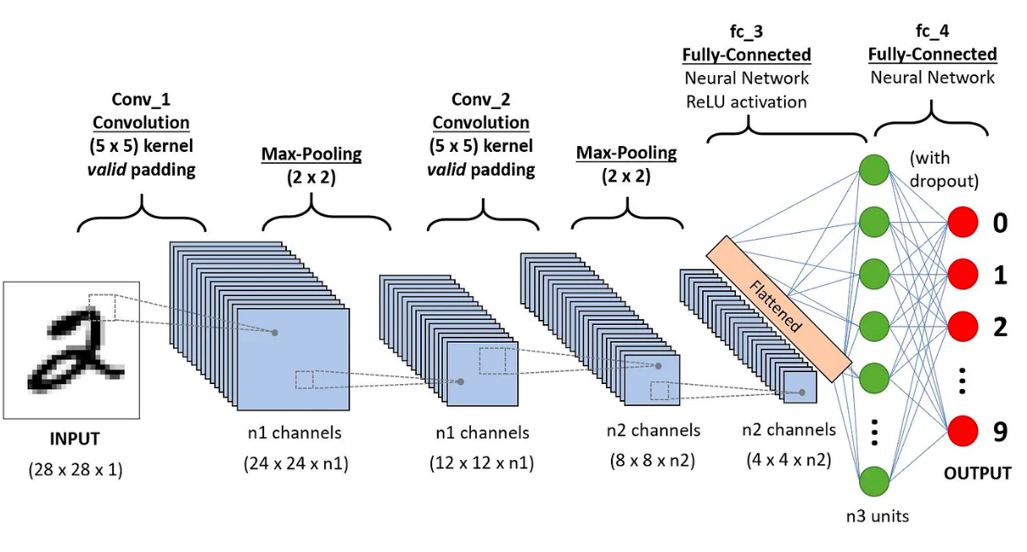**Advantages of CNNs for Image Classification**

1. **Automatic Feature Extraction**:
   * CNNs can automatically learn relevant features from images, such as edges, textures, and objects, without requiring manual feature engineering. This makes them highly adaptable to various image datasets.
2. **Translation Invariance**:
   * CNNs can recognize objects in images regardless of their position. This means the network is able to detect an object whether it is at the top, bottom, or center of an image, making it more robust compared to traditional machine learning algorithms.
3. **Efficient Computation**:
   * CNNs take advantage of shared weights and local connectivity. Each convolutional layer uses the same set of filters across the entire image, significantly reducing the number of parameters and making the model more computationally efficient.
4. **Effective for Large-Scale Image Data**:
   * CNNs perform well on large-scale image classification tasks, often achieving state-of-the-art results in competitions like ImageNet. They can also be extended to other visual tasks like object detection, segmentation, and image generation.

**Disadvantages of CNNs**

1. **Require Large Datasets**:
   * CNNs perform best with large amounts of labeled data. For smaller datasets, they may struggle to generalize well, leading to overfitting. To overcome this, techniques like data augmentation or transfer learning are commonly used.
2. **Computationally Expensive**:
   * Training CNNs requires significant computational power and time, especially when working with large networks and high-resolution images. Training CNNs on GPUs (Graphics Processing Units) is typically necessary to speed up the process.
3. **Complex Architecture Tuning**:
   * The design and tuning of CNN architectures require significant expertise. Factors such as the number of layers, filter size, and pooling strategies can greatly influence the performance of the model.
4. **Lack of Interpretability**:
   * CNNs function as black-box models, meaning it's difficult to understand exactly how the network arrives at a particular classification. This can be a drawback when explainability is required in sensitive applications (e.g., medical diagnoses).

**Applications of CNNs in Image Classification**

1. **Medical Image Analysis**:
   * CNNs are used in medical imaging to classify diseases based on images such as X-rays, CT scans, and MRIs. For example, they can detect tumors or classify the type of disease present in a given medical image.
2. **Autonomous Vehicles**:
   * Self-driving cars rely on CNNs to classify objects in their surroundings, such as pedestrians, traffic lights, road signs, and other vehicles. This is critical for making real-time driving decisions.
3. **Facial Recognition**:
   * CNNs are at the heart of many facial recognition systems. They can classify different faces in a database and are widely used in security, authentication, and surveillance applications.
4. **Retail and E-commerce**:
   * In retail, CNNs are used to classify products based on images. For instance, e-commerce platforms can categorize products into various classes (e.g., clothing, electronics, furniture) based on their visual attributes.
5. **Content Moderation**:
   * Social media platforms and websites use CNNs for image classification to detect and remove inappropriate content, such as violence or nudity. CNNs help automate the process of moderating large volumes of user-generated content.
6. **Object Detection and Recognition**:
   * CNNs power advanced object recognition systems that are used in real-time applications such as surveillance, robotics, and augmented reality. These systems can identify multiple objects in an image and track them.

**Conclusion**

Convolutional Neural Networks (CNNs) are one of the most powerful tools for image classification tasks, especially for multiclass classification. Their ability to learn complex visual features, robustness to translation, and efficiency in feature extraction make them the go-to solution for many image-related tasks. However, CNNs require large datasets, are computationally intensive, and can be difficult to interpret, which necessitates careful model design and infrastructure support. Despite these challenges, CNNs have revolutionized the field of image analysis and have broad applications across industries, from healthcare to autonomous vehicles.